1. **What do you mean by cells in an excel sheet?**  
   *Answer* – In Microsoft excel a cell is a rectangular box that occurs at the intersection of a vertical column and a horizontal row in a worksheet.

As shown in above image a rectangular box which is F9 is a cell of excel where F represents columns and 9 represents rows.

1. **How can you restrict someone from copying a cell from your worksheet?***Answer*–To protect someone from copying the cell of our worksheet we must set the password to our worksheet and uncheck the required option in that.  
    First go to Menu bar < Review < Protect sheet after that we will get several options for protection now select required one.  
    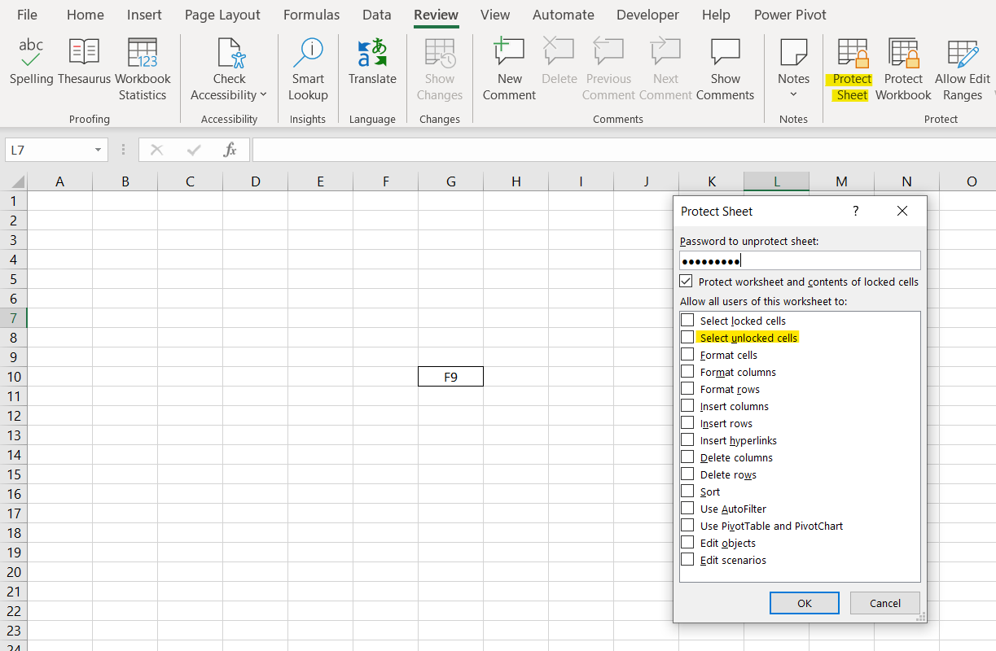
2. **How to move or copy the worksheet into another workbook?**Answer – To move or copy the worksheet into the another workbook we have to right click on that worksheet and select Move or Copy option, New window will open where we have to select required workbook from “To book” where we want to move or copy the selected workbook and also can select before sheet and check Create a copy box and then OK.  
     
   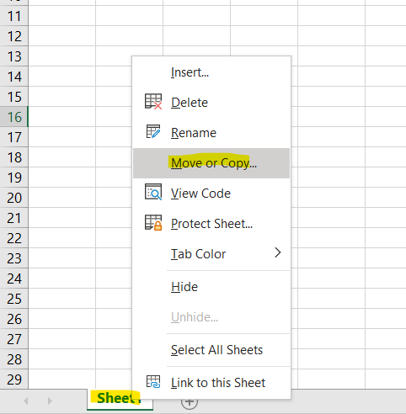A screenshot of a computer

   Description automatically generated
3. **Which key is used as a shortcut for opening a new window document?***Answer* – “CTRL + N” is used as a shortcut for open a new window document.
4. **What are the things that we can notice after opening the Excel interface?***Answer –*There are certain things that to be noticed after opening the Excel interface…  
    a. Formula Quick Menu

b. Formula Bar

c. Name Box

d. Ribbon Interface

e. Quick Access Toolbar

f. Zoom Percentage Indicator

g. Zoom Slider Control

**6.When to use a relative cell reference in excel?** *Answer –*We must use relative reference when any defined formula needs to copy to all entire below cells. Relative cell references are used whenever calculations need to be repeated.

Please refer to the below example…  
 Ex. Here are the data in which we need to find the difference of 2016 year data and 2018-year data, so that we applied the formula “**=A2-B2**” and if need to applied same formula for all below rows then drag or copy same formula that’s call relative reference and its use.  
  
